Steezus Christ
Concept Art
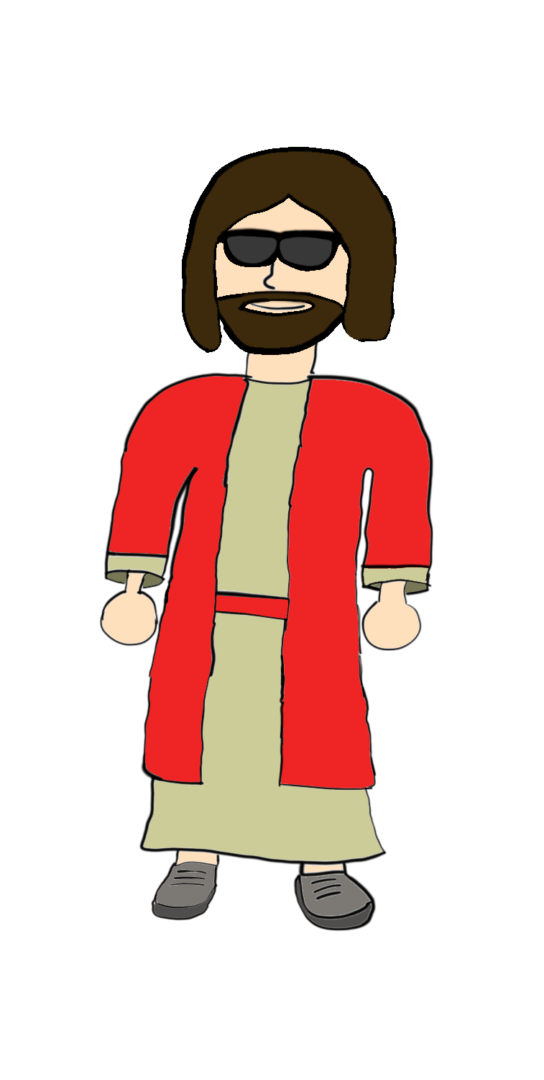
Description
A cheaply made Jesus figure that serves as an announcer and mentor for Little Guy

Backstory
“In Steezus Christ’s name we shred, amen”
Steezus Christ descended from the heavens to assist Little Guy’s pursuit of the gnarliest shred. After coming from Abuela’s nightstand he made his way to the child’s room where he meets Little Guy. After hearing that Little Guy wants to skate but doesn’t know how, Steezus Christ takes Little guy under his wing and teaches him the ways of shredding.

Special moves, mechanics, and/or equipment
Steezus Christ acts as the narrator, menu guide, and shop for the game. In the menu’s he will appear and sometimes comment on settings and what they do. Before Starting rounds he will also act as a shopkeeper for new skills and customization options. In the middle of a round he will act as an announcer and possibly add obstacles to further challenge Little Guy. His signature move is the crucifix as seen in the reference images

Reference Images
